# CNN – Max de Goede

## Introduction

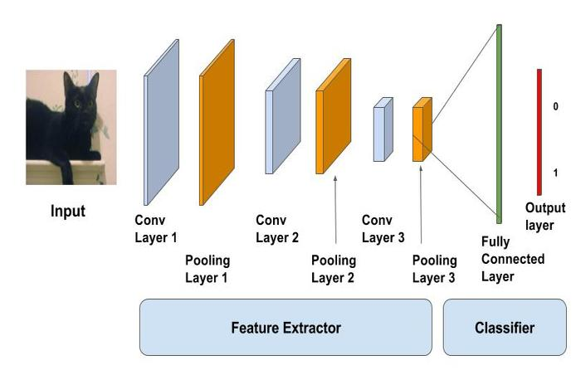Convolutional Neural Network (CNN) is an neural network that can help classify images and recognize objects within an image (It’s only use is not image recognition/object detection, but it is the main one). How does this work for images? The algorithm gets an image, the image then goes through multiple layers of reshaping and resizing. Why is this done? By doing this the network will find patters in the data (images) and be able to classify (label) objects within images (or images in a whole).

What have I done for this topic?

* I started with this topic by going to canvas and following the theoretical background and learning about CNN in general.
* I followed the theoretical background by looking at the ‘How to apply?’ Tutorials. Where I worked on creating edges with grayscale for example. With this I understood the principal of CNN and how it worked In the background.
* At last was the standing on the shoulders of giants, at the beginning it took me some time to understand why this exercise was called like this. Now I understand, since the principle of the exercise is to reuse the trained algorithms (weights) and be able to reapply them.

## Used Methods

Personally I had a lot of issues trying to find a workaround on how to get one of these methods to work. I kept getting constant errors and even with the help of my groupmates, I did not manage to get *Image captioning & Semantic Image segmentation -Deeplabv3+*  to work. So what I did first was work on the MNIST dataset, just to get myself in the mood of things and see if I could do anything with a fresh mind. This sadly did not work, so I resulted to one of my last options which was to ask for one of my groupmates for help with their algorithm (Someone that got an algorithm to work). I soon discovered that the algorithms that I tried to use before hand terrible documentation in how to implement a trained network with the weights compared to the one Tobias (my group mate) used for his. The documentation there was simple and straight forward, in other words easy to follow.

But setting up the environment for Mask-R CNN was not as easy as I thought it would be. I had many issues that Tobias did not encounter, primarily with some libraries I had to install. For some reason, the library *‘Shapely’* could not get installed on my laptop. I tried for a long time to get it to work looked at many solutions but nothing worked. This took me back to the main page on the Git, where in the readme it says that shapely is not necessarily required for imgaug (the library that required shapely). Only when specifically called for and that I could skip this installation. But sadly this was no solution as through anaconda, it constantly tried to install the shapely library. This forced me to dive into the coco Code and manually adjust some parameters, so shapely would not automatically be installed with imgaug. Once this step was done and over with, I could finally start classifying.

## Results

The results from Mask-R CNN can be found with below.



## Conclusion

Before I ever had a lesson of CNN, I thought CNN was an American news channel. CNN is probably one of my favorite neural networks. I think it is extremely cool how CNN can classify objects within an image. I am no expert in CNN, and this is also something I don’t intend on becoming. But I understand the concept and how it works, I’m sure if I would sit down with people that are very knowledgeable on this subject I will be able to follow the conversation they are having, but will not be able to bring in any input. But I do know the moment I am sitting with people who have little to no knowledge on this subject that I can explain the core and how this can benefit their business core. In other words, I can surely translate my CNN knowledge into what a business requires and could need from it.

It was funny to see how sometimes the image classification could be very wrong, by either lack of data or wrong perception of the object/animal.